Diversions Roscommon Harriers 10 mile

Ardsallagh Woods road – L7055
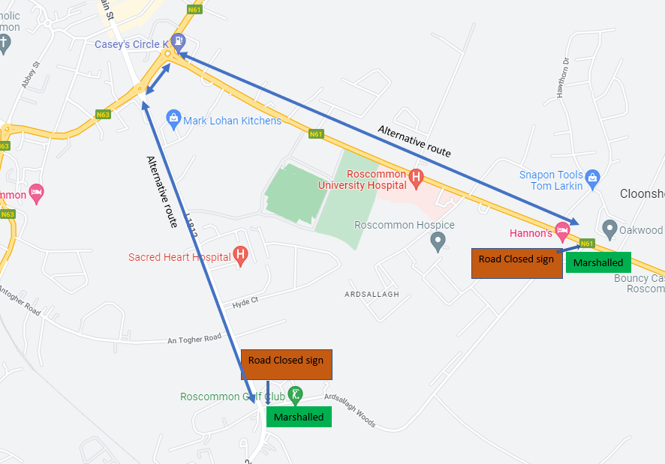
Alternative Route
Alternative Route

Road closed in Red. We will be placing Marshals at Hannon’s Hotel and the golf course from 9:00 am to 14:00pm on Sat. June 27th, 2026. Local traffic will be allowed to use the road but will be diverting other traffic towards the town.
Turville – L7081 – Galway Road N63 junction to Junction with L1812 road

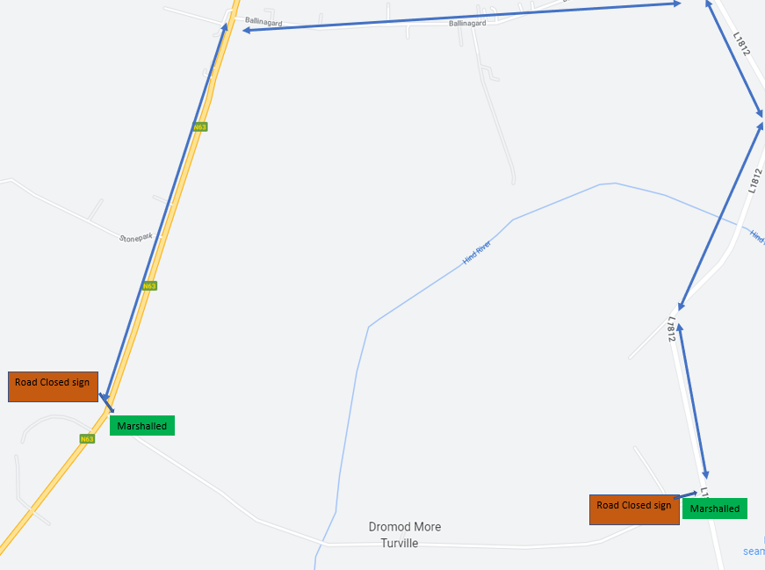
Alternative Route
Alternative Route
Alternative Route
Road closed in Red, we will be placing Marshals at N63 Junction and L1812 from 11:00 am to 12:00pm on Sat June 27th, 2026. Local traffic will be allowed to use the road, but we will be diverting other traffic towards the town. Once all runners have completed this section, road will be re-opened.

