

**BHIS Historic Thatched Buildings Stream 2026**

**Appendix I – Application Form A**

**TO BE COMPLETED BY APPLICANT AND SUBMITTED TO THE RELEVANT LOCAL AUTHORITY**

*Applicants should refer to:*

*BHIS Historic Thatched Buildings Stream 2026 Circular*

**IMPORTANT NOTE**

All sections of the form must be completed by the applicant. Incomplete applications will not be considered.

For further information please contact your relevant local authority

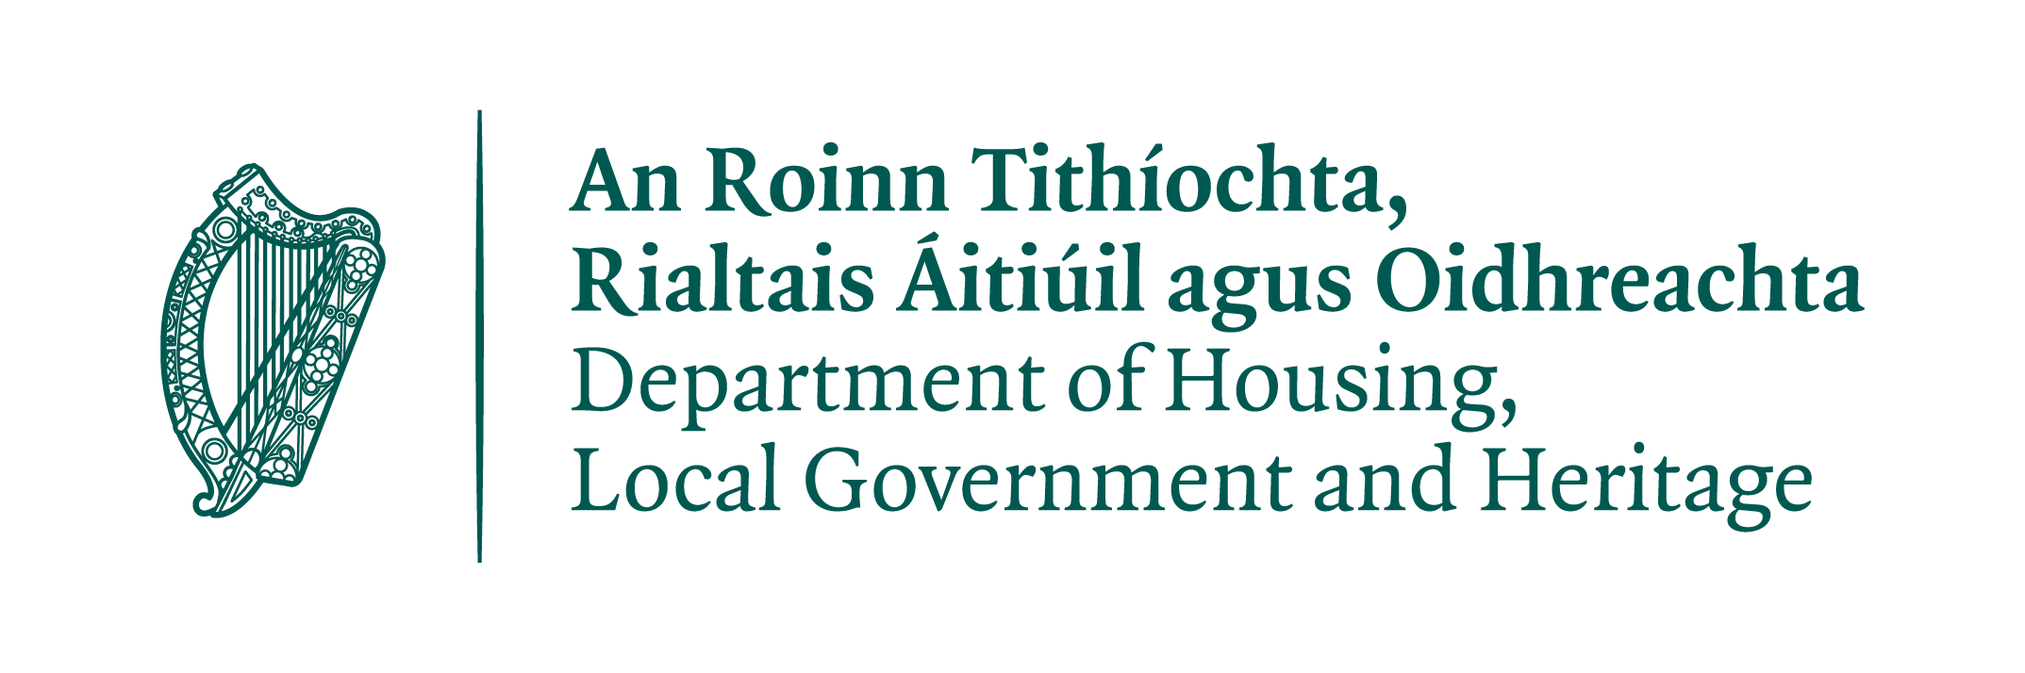

**SUMMARY DETAILS**

|  |  |
| --- | --- |
|  | |
| Owner’s Name: |  |
| Name and address of structure funding is sought: |  |
| Proposed works: |  |
| Amount of funding sought: |  |

**APPLICANTS MUST NOTE THE FOLLOWING WHEN COMPLETING THIS FORM**

* This form **(Form A)** must be fully completed
* Please **type** the relevant information or use BLOCK CAPITALS if handwriting
* All dates should be entered in the format **DD/MM/YYYY**
* **Photographs must be included which illustrate the project before works commence as per Section 4**
* Details of how the remaining cost of the works, i.e. those not covered by the amount of grant funding sought, is to be met, must be stated in **Section 6**.
* The applicant must also indicate any grants, subsidies or assistance from statutory bodies, or sponsorship or assistance from a non-statutory source, received or being sought in **Section 7**.
* All proposed works should follow the conservation principles in the Department’s [*Architectural Heritage Protection Guidelines for Planning Authorities* (2011)](http://www.ahg.gov.ie/en/Publications/HeritagePublications/BuiltHeritagePolicyPublications/Architectural%20Heritage%20Protection%20Guidelines%20(2011).pdf) and [*Advice Series*](http://www.ahg.gov.ie/en/Publications/HeritagePublications/BuiltHeritagePolicyPublications/)publications. These are available from Government Publications or through any bookshop or to download from:

<https://www.buildingsofireland.ie/app/uploads/2019/10/Architectural-Heritage-Protection-Guidelines-for-Planning-Authorities-2011.pdf>

<https://www.buildingsofireland.ie/resources/>

* Bats are protected under the EU Habitats Directive. Any proposed works which may affect bats or their roosts should take cognisance of DHLGH’s bat mitigation guidelines. These are available at: <https://www.npws.ie/publications/search?title=bat+mitigation&keyword=&author=&series=All&year=&x=0&y=0>

**1. Project Details**

|  |
| --- |
|  |

**Please provide a short, concise description of the nature of the works to be undertaken (circa 50 words):**

|  |
| --- |
|  |

**2. Applicant Details**

|  |  |  |
| --- | --- | --- |
|  | | |
| Name: |  | |
| Are you the main point of contact (if not, please specify alternate contact): | Y/N: | |
| Address: |  | |
| Telephone/Mobile Number: |  | Email: |
| Charity Number: *(if applicable)* |  | |
| Tax Reference Number: |  | Date: |
| Are you the owner of the property: | Y/N: | |
| If you are not the owner, please provide their contact information here.  Please also indicate if their consent has been obtained to apply under this scheme and attach evidence of their consent (such as a signed letter) to this Form. |  | |

**3. Structure Details**

|  |  |
| --- | --- |
|  |  |
| Address of Property: |  |
| Eircode (must be provided): |  |
| Estimated year of construction: |  |
| Is the property (please choose one): | * Owner-occupied dwelling * Rented dwelling * Commercial premises * Other: __________________________________ |

**4. Project Description/Method Statement**

|  |  |  |
| --- | --- | --- |
|  | **Description of Works** | |
| Provide a description or Method Statement to outline the proposed works, using an additional page if necessary.  **This must be done in consultation with the experienced thatcher or conservation professional who is overseeing the works** (see Section 5 below)  Please include:   1. A summary description of the structure, including its age and significance 2. A description of the works proposed, including whether it is a **full re-thatch or smaller repair work** 3. The **type of materials** to be used, such as thatching in straw or reed 4. Any works proposed to the chimney or internal structure of the roof 5. **Please include photographs with your application** which illustrate the condition of the property before works commence |  | |
| Estimated start and finish dates of proposed works **MUST BE PROVIDED** | Start: | Finish: |

**5. Details of Thatcher/Conservation Professional to be employed on the project**

|  |  |  |
| --- | --- | --- |
|  |  | |
| Name: |  | |
| Address: |  | |
| Telephone/Mobile Number: |  | Email: |
| Tax Reference Number: |  | Date: |
| Summary of Experience: |  | |

**6. Expenditure in relation to proposed works**

|  |  |
| --- | --- |
|  |  |
| Estimated **Total Costs of Works** for which funding is being sought (please specify if including or excluding VAT): | € |
| Total amount of grant funding sought: | € |
| Amount of matching funds (i.e. the amount that you are paying to meet the full cost of the project in addition to the grant): | € |
| Source of matching funds (e.g. own resources/savings): |  |

**7. Other Grants & Reliefs**

|  |  |
| --- | --- |
|  |  |
| Is VAT recoverable? |  |
| Have you applied for or availed of other funding/Tax Reliefs e.g. Vacant Property Refurbishment Grant or Housing Grant for the Renewal or Repair of Thatched Roofs of Houses (Ballina)? |  |

**8. Additional Contractors/Tradespersons employed on the project (if applicable)**

|  |  |  |
| --- | --- | --- |
|  |  | |
| Name: |  | |
| Type of trade: |  | |
| Address: |  | |
| Telephone/Mobile Number: |  | Email: |
| Tax Reference Number: |  | Date: |

**If necessary, copy this page to include additional contractors/tradespersons**

**9. Declaration by Owner/Applicant**

|  |
| --- |
|  |

I, the applicant, certify that:

1. I understand and fulfil all the terms and conditions of the BHIS Historic Thatched Buildings Stream 2026.
2. The information provided in the application form and supporting documents is correct and I will notify the relevant local authority if there is any change in that information.
3. I am providing at least €_____________ from my own private resources towards these works
4. My tax affairs are in order.
5. I understand that payment of funds by a local authority under this scheme does not imply a warranty on the part of the authority or the Minister for Housing, Local Government and Heritage in relation to the suitability or safety of the works concerned or the state of repair or condition of all or any part of the structure concerned or its fitness for use.
6. I understand that the local authority or the Department of Housing, Local Government and Heritage may make any enquiries that it considers necessary to establish my eligibility for funding under this scheme, and that the local authority’s and the Minister’s decisions are final.
7. I understand that information provided on this form in relation to the structure, including its address and the amount of grant funding awarded, may be displayed on Department’s or the local authority’s website. In making an application, I acknowledge that any images provided or taken as part of the project may be utilised for promotional or educational purposes by the Department or the local authority.

**Applicant’s Signature: _______________________ Date: _________________**

Completed applications shall be marked **“Built Heritage Investment Scheme 2026”** and submitted before **5.00pm on Friday 26th September 2025** either by post to: Heritage Office, Roscommon County Council, Áras an Chontae, Roscommon, Co Roscommon F42 VR98 or by email to heritage@roscommoncoco.ie