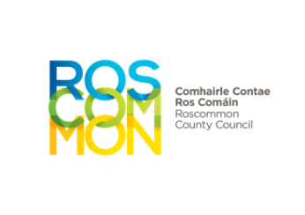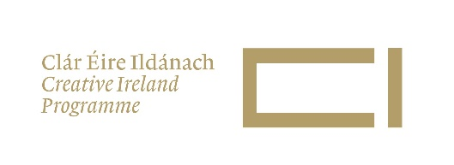

**Cruinniú na nÓg 2023**

**Enabling the Creative Potential of Children and Young People**

**APPLICATION FORM**

|  |  |  |  |
| --- | --- | --- | --- |
| Organisation Name |  |  |  |
| Creative Name |  |  |  |
| Key Contact |  | Phone |  |
| Address |  | Email |  |

**Project Plan -** Please give a description of your proposed project, structure and format of activity/event(s), duration, venue (state indoor or outdoor) or context (online or other). Please note part of the plan **must include an activity/event on Saturday 10th June.** (max. 500 words).

|  |
| --- |
|  |

**Partnership Plans**

* Who are the creative practitioner(s) and the organisation(s).
* Why you are working together
* What previous experience do you have of delivering creative and participatory projects with children and young people and/or for young audiences. (max. 250 words)

|  |
| --- |
|  |

If you have a link which can give us some further relevant information about online or video/sound content, please leave it here. (Video files sent as attachments will not be considered- please send **links only**, .doc, .pdf and .jpg can be sent as an attachment with the application)

|  |
| --- |
|  |

**Participants / Audience**

* Who are the participants in this project and who is your target audience for this project – age range, social /cultural background?
* Do these activities build on previous work or are they targeting young people who have not had these opportunities before?
* How have young people been involved and included in deciding and planning the project you are proposing?
* How does your chosen platform or method of delivery suit your selected participants/audience?
* What is the size of the audience you can accommodate?

|  |
| --- |
|  |

**Amount sought** - Please outline all costs involved in your proposal.

The budget available for one proposal will be a maximum of €1,000 for co-creation or participatory projects depending on the scope of the proposal (how many people are involved in producing, audience size, technology used).

|  |
| --- |
|  |

**What is your total cost for the event? €_____________________**

**Other Funding? €_____________________**

**Amount requested from Roscommon County Council? €_____________________**

Max €1000

Application form and all supporting material must be completed and submitted by email to **creativeireland@roscommoncoco.ie**

**Closing date for receipt of completed proposals is 4pm Monday 20th March 2023**