




Information
Brochure
IPB Pride of Place 2026
Co-operation Ireland, it's local authority partners and it's headline sponsor, IPB Insurance, are proud to present the prestigious Pride of Place Competition for the 24th consecutive year. The purpose of the competition is to acknowledge the work being done every day by communities all over the island of Ireland.


A note from our Chairperson


“Co-operation Ireland, its local authority partners, and its headline sponsor IPB Insurance are proud to present the prestigious IPB Pride of Place Competition for the 24th consecutive year. Last year we celebrated with communities from all over the island at a magnificent awards dinner in the lovely Strand Hotel in Limerick City, hosted by Limerick City and County Council. I congratulate all the communities present, who were already winners and community exemplars by being nominated by their local authority to represent their place. I wish to thank Co-operation Ireland for their ongoing commitment to leading this competition and I want to particularly welcome IPB Insurance as the headline sponsor for the fifteenth consecutive year. I acknowledge IPB’s recognition of the importance of looking after the communities their customers serve. I also wish to congratulate IPB as it celebrates 100 years as Ireland’s only indigenous mutual insurer.
I wish all the communities and groups in this year’s competition every success and thank them for their participation. I look forward to visiting many of them, with our experienced volunteer judges.”
Tom Dowling Chairperson, IPB Pride of Place (In association with Co-operation Ireland)

How to enter
The IPB Pride of Place competition is open to all local community groups, by way of local authority nomination only. The closing date for receiving Expression of Interest forms via email for Roscommon County Council is Friday 1st May 2026.
Entry is by way of council nomination. Each local authority may nominate groups in up to a maximum of five categories and one entry only in any individual category. Please note that population categories are judged on all aspects of the community and single-issue categories are judged on the specifics of that category.

2026 Categories
CITY CATEGORIES
- Population 0-300  - Population 300-1000  - Population 1000-2000  - Population 2000-5000  - Population Over 5000  - Creative Communities | - Urban Neighbourhood under 3,000  - Urban Neighbourhood over 3,000  - Creative Communities  - Climate Action & Biodiversity  - Community Youth Initiative  - Inclusive Communities  - Community Wellbeing Initiative
- Climate Action and Biodiversity
- Community Youth Initiative
- Inclusive Communities
- Community Wellbeing Initiative
- Community Tourism Initiative
- Age Friendly Communities
- Urban Neighbourhoods and Housing Estates

2026 Timeline
Application Deadline: Friday 1st May
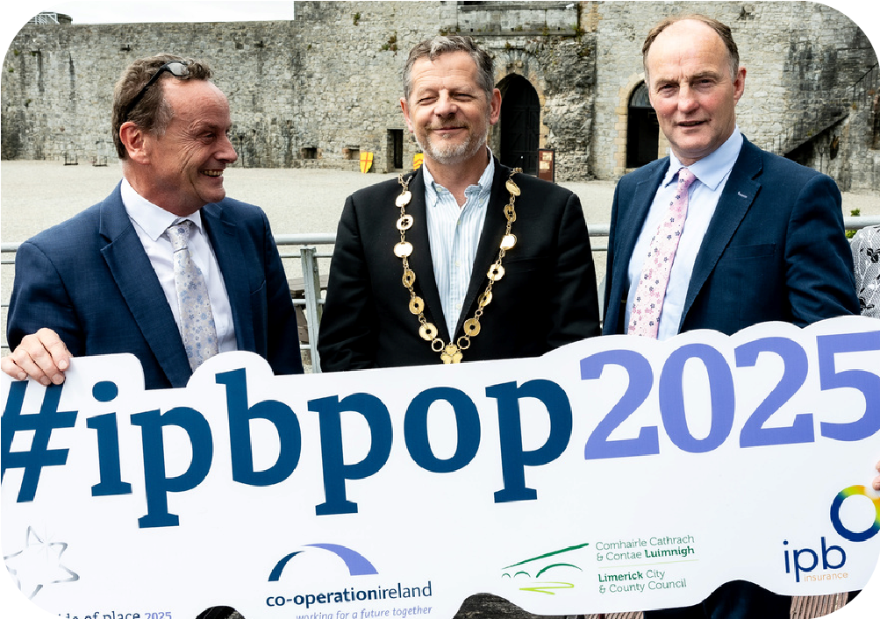
Complete Expression of Interest form and submit via email to prideofplace2026@roscommoncoco.ie
Judging Period: Mid-June to Early September Judges will visit entries during this time.
Awards Ceremony: Saturday 24th October The Convention Centre Dublin

Contact us
If you require any support or any additional information on Pride of Place 2026 for County Roscommon, please contact:
prideofplace 2026 @roscommoncoco.ie

