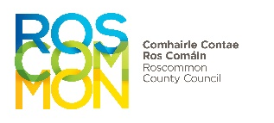
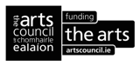

Roscommon County Council Arts and Culture Office

ROSCOMMON CHAPBOOK BURSARY 2026

APPLICATION FORM

NAME……………………….………………………………………………….…………………………..............................................

ADDRESS…………………..……………………………………………………………………………...............................................

……………………………………………………………………………………………………………..................................................

CONNECTION TO ROSCOMMON:………..………………………………………….......................................................

TEL……………………………………............................... EMAIL………………………………………….………………...............

List below the titles of either the poems or the stories that you propose to include in the chapbook.
All applications must be accompanied by proposed content of the chapbook (poems or stories) and a current biography and/or CV, outlining details of career to date.

Signed:___________________________________ ________ Date:_______________________

DEADLINE: 4pm Thursday 16th July 2026

Return Completed Applications to:
Email: artsofficer@roscommoncoco.ie
Roscommon Chapbook Bursary 2026 (applicant name) typed in the subject box

