ROSCOMMON CHAPBOOK BURSARY

The Roscommon Chapbook Bursary has been established to assist Roscommon writers with the costs associated with publishing a modest collection of poems (15 – 20) or a compact collection of short stories (3 – 6). One award of €600 will be offered in 2023.

CONDITIONS
- All applicant writers must have a connection with the county of Roscommon (born in, living in, currently working in, went to school in).
- A typical length of a chapbook is 30 pages. This is a guideline only, though submissions that fall considerably short of this, or which are considerably longer, may not be considered suitable.
- Grant aid provided by Roscommon County Council together with the Arts Council of Ireland must be acknowledged in all publicity material associated with the project and in the published chapbook. Roscommon County Council reserves the right to publicise the awarding of the bursary. The successful applicant will receive a copy of the Roscommon County Council and Arts Council logos.
- The intended work must be completed and proof of publication will be necessary for the successful applicant to claim the bursary. Two copies must be submitted to Roscommon County Council Arts Office at the time of publication.
- The Bursary Award will be adjudicated by poet and author Ger Reidy.
- All applicants will be advised of Council’s decisions in writing.
- All applications must include:
- The completed Application Form
- Proposed content of the chapbook (poems or stories)
- A current biography and/or CV, outlining details of career to date.

Application forms are available here:
http://www.roscommoncoco.ie/en/services/community/arts-office/literature.html
For further information, please contact Áine Butler at abutler@roscommoncoco.ie or telephone (09066) 37271

Return Completed Applications to artsofficer@roscommoncoco.ie with ’Roscommon Chapbook Bursary (applicant name)’ typed in the subject box.

OR Post your entry to: ROSCOMMON CHAPBOOK BURSARY 2023, Roscommon Arts Office, Áras an Chontae, Roscommon, F42 VR98.

The closing date for receipt of completed application forms is 5pm Friday 19th May 2023.
Late applications will not be considered.

Roscommon County Council reserves the right not to award a bursary should the submissions, in the opinion of the adjudicator and the Council, not achieve a sufficiently high standard.

The name of the recipient will be announced in local media and online at http://www.roscommoncoco.ie/en/Services/Comm_Ent/Arts_Office/literature.html
The date of the bi-annual Awards Ceremony will be announced in 2024.

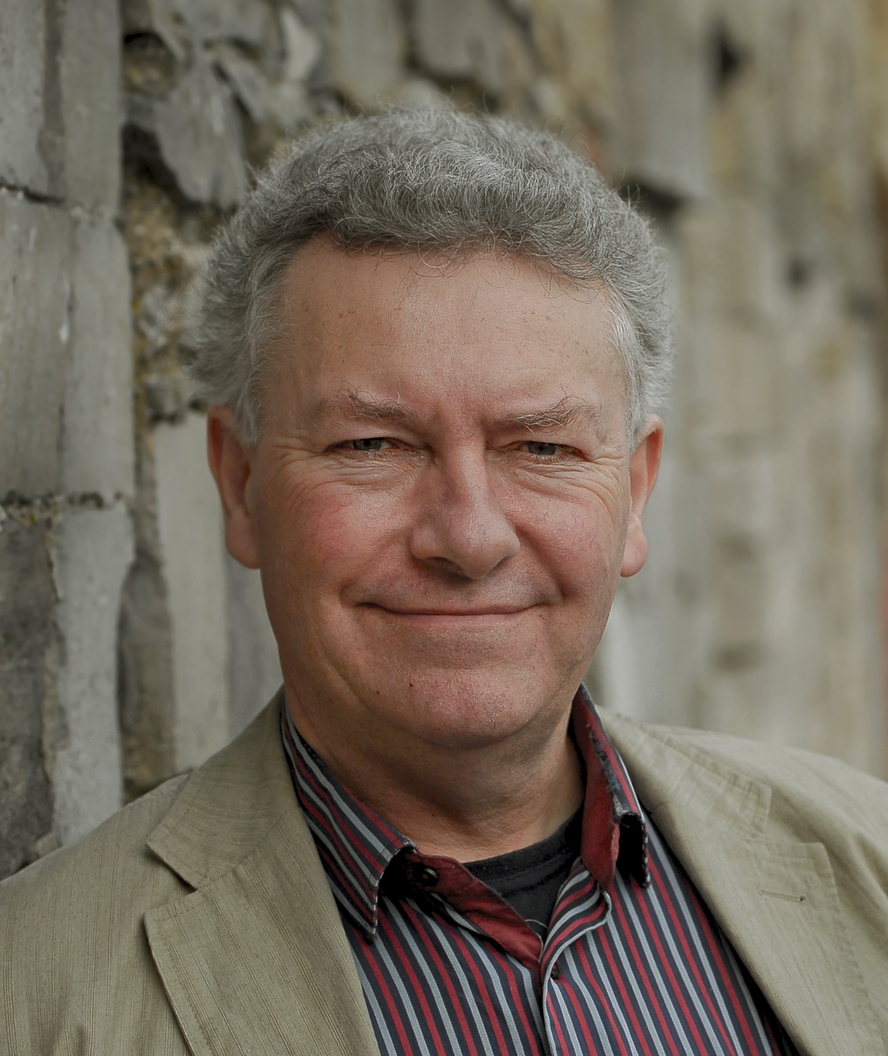

Adjudicator Ger Reidy was born near Westport, Co. Mayo. He has won several national poetry competitions including the Allingham, the Maria Edgeworth, the Boyle Arts Festival prize on two occasions and has been the recipient of a number of bursaries and residencies sponsored by the Arts Council and Mayo County Council. His first collection, “Pictures from a Reservation”, was published by Dedalus Press.

He has been published in many literary journals including Poetry Ireland review, The Irish Times, both at home and abroad, and has read at numerous literary festivals, including the Cúirt Festival in Galway in 2010 and 2016, where his second collection, Drifting under the Moon, and his collection of short stories Jobs for a Wet Day was launched. He has been translated into Russian and recently into Turkish. Ger’s latest collection Before Rain was shortlisted for the Pigott Prize at Listowel writers week and his collection of short stories Jobs for a Wet Day was nominated for the Edge Hill prize - the best collection of short stories in the British Isles.

