ROSCOMMON NEW WRITING AWARD 2023
for Short Fiction
First Prize: €1000

The ROSCOMMON NEW WRITING AWARD 2023 is organised as part of the county’s Literary Development Programme. It is funded by Roscommon County Council and The Arts Council of Ireland, supported by the Roscommon Herald and Shannonside FM.
The winner will receive a monetary prize of €1000 and will have their winning entry printed in the Roscommon Herald.
Two runners-up will receive €100 each.

The Competition will be adjudicated by Tanya Farrelly.
Tanya Farrelly is the author of four books. Her debut short fiction collection When Black Dogs Sing (Arlen House, 2016) was longlisted for the Edge Hill Short Story Prize and named winner of the Kate O’ Brien Award 2017. Two novels: The Girl Behind the Lens and When Your Eyes Close were published by Harper Collins, London (2016/2018). She curated and edited The Music of What Happens, an anthology of poems, stories and essays published in aid of Purple House Cancer Support Centre (New Island, 2020). Her latest book: Nobody Needs to Know, a short fiction collection, was published in November 2021 by Arlen House.

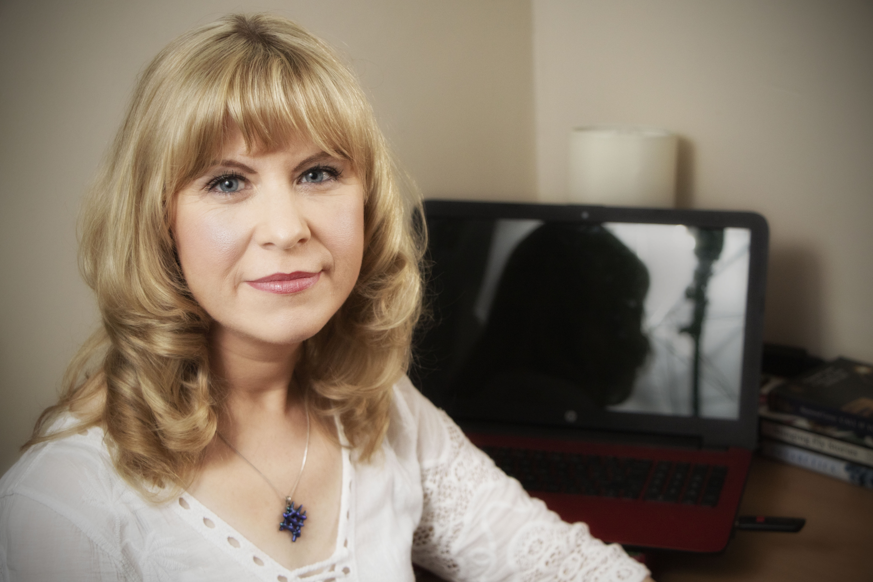

Closing date for entries is 5pm Friday, 19th May 2023.

For queries, please contact Áine Butler at abutler@roscommoncoco.ie. Tel (09066) 37271

The Roscommon New Writing Award Competition Rules

- Short stories only will be accepted.
- The competition is open to anyone over 18. All entrants must have a connection with the county of Roscommon (born in, living in, currently working in, went to school in).
- Previous first prize winners may enter but will not be eligible for the first prize.
- Writers may submit up to two entries.
- Typed entries (handwritten entries cannot be accepted) must be no more than 2000 words. Mark the number of words in your entry on the bottom of the page. Entries over the 2000-word limit will be automatically disqualified.
- Include your name, address and contact details, plus your connection to the county. INCLUDE THESE ON A SEPARATE PAGE, NOT ON YOUR ENTRY.
- There is no entry fee. All entries must be received by 5pm Friday, 19th May 2023.
- The competition will be adjudicated by Tanya Farrelly. The judge’s decision is final.
- Roscommon County Council reserves the right to publicise the awarding of the Award.
- Email your entry to: artsofficer@roscommoncoco.ie .Title your email ROSCOMMON NEW WRITING AWARD 2023.
OR Post your entry to: ROSCOMMON NEW WRITING AWARD 2023, Roscommon Arts Office, Áras an Chontae, Roscommon, F42 VR98.

The names of the shortlisted writers will be announced in local media and online at http://www.roscommoncoco.ie/en/Services/Comm_Ent/Arts_Office/literature.html
The date of the bi-annual Awards Ceremony will be announced in 2024.

