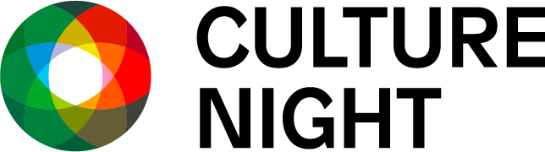

Culture Night Roscommon 2025

Friday 19th September, 5pm - late

**Artist Registration Call-Out**

Culture Night 2025 will take place on Friday 19th September from 5pm till late.

We are delighted to open the call out for Culture Night Roscommon 2025 and seek artists and cultural practitioners of all art forms to register expressions of interest to participate in this year’s programme.

Culture Night is a national moment celebrating culture, creativity and the arts, and seeks to actively promote the belief that this rich and varied culture is alive, treasured and nurtured in people's lives today and every day. All events are free of charge.

A similar call out will be made to Roscommon cultural venues who would like to participate, and pairings can be made between venues and artists if this is not already indicated.

Culture Night celebrates the arts, knowledge and stories, language, traditions and rituals, techniques and skills, food and drink, shared values and sense of community.

This registration process is for Roscommon-based artists who wish to be included in the Culture Night Roscommon programme. The process is only open to practitioners willing to be paired with dedicated cultural venues indoors/outdoors - these include galleries, theatres, libraries, historical houses, museums, parks, community centres and artist studios.

Geographical spread will be considered when allocations are assessed. Depending on the level of interest, the value of funding is likely to be in the region of €250 - €500 per artist/venue.

If you wish to be considered for an artist/venue pairing for Culture Night Roscommon 2025, please fill and return to [artsofficer@roscommoncoco.ie](mailto:artsofficer@roscommoncoco.ie) this **Artist Registration Form** - <https://www.roscommoncoco.ie//!TD1N2R>

You can also email any queries to artsofficer@roscommoncoco.ie

**Deadline for receipt of expressions of interest is 5pm, Thursday June 12th 2025.**