
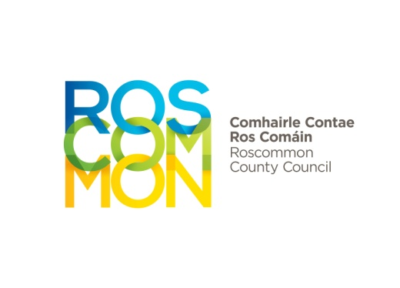
Municipal Districts
Funding Scheme 2026
- Introduction
1.1 | The sum of €125,000 is available to each of the three Municipal Districts in 2026. This funding has not been allocated to specific projects and provides elected members with discretionary funding to allocate to projects that aim to benefit communities in the Municipal District.
1.2 | It is hoped to increase this level of funding in the coming years, but in doing so it is important that guidance is made available to elected members to ensure value for money is obtained and where funding is given for projects it makes real difference.
1.3 | Each Municipal District will be responsible for allocating the €125,000 or amount agreed as per the budget process, to the various headings identified in paragraph 2.1, taking account of local needs and priorities. For avoidance of doubt, each Municipal District will be autonomous, leading to different amounts being allocated among the various headings. This, however, does not prevent the three Municipal Districts discussing budget strategies and agreeing to proceed in a uniform manner.
1.4 | The budget for each element will be fixed at the Municipal District Budget Plan meetings held in September/October, in preparation for the following financial year. This will provide a level of certainty regarding planning for projects and ensure deadlines are met in awarding potential grants or match funding to community groups.
1.5 | Any funds unspent balances will roll over on an annual basis.  Note:  - The terms and conditions of the scheme will be reviewed on an annual basis.  - The project will be fully costed, managed and delivered with full responsibility and liability attaching to the applicant for its completion.
- Eligible Projects
2.1 | The €125,000 and any future increases agreed as part of the budgetary process will be used to fund:  - Dereliction  - Infrastructure  - Economic & Community Development  - Tourism
2.2 | A project will not be provided with Municipal District funding if funding has already been agreed and allocated from another section of the Council, (i.e. no double funding, including Amenity Grants / Burial Ground Grants). No single project can claim grants on an annual basis from this fund.
2.3 | Projects which help the Council meet its targets within LECP etc… around social inclusion and the aims outlined in the Local Development Strategy will be given priority.
2.4 | Projects which are ineligible include:  - Projects already funded by the Council  - Projects which should be met by other types of Exchequer funding (i.e. schools, nursing homes, etc.)
3 Calls for Funding and Requirements
3.1 | The minimum amount of funding that a group can apply for is €1,500, with a maximum of €15,000. A maximum of 95% of the total cost of the project is available.
3.2 | Any applicant for funding must provide (if applicable)  - Evidence of Legal Structure (e.g. Limited Co., Ad-hoc Group etc.)  - Evidence of registration for VAT (if applicable)  - Proof of tax clearance (please include copy of letter from Revenue)  - Evidence of Insurances  - Evidence of Registration with the Public Participation Network (PPN)  - Child Protection Policy  - Details of all funding streams  - Meet Health and Safety requirements
3.3 | Should an organisation wish to apply for funding from the Local Development Strategy as well as funds from the Municipal District, they must be aware of state aid rules outlined in appendix 1.
4 Application Process
4.1  4.2 | Applications must be made via My Online Services at:  https://myonlineservices.roscommoncoco.ie  Before you begin you will be required to register for My Online Services at  https://myonlineservices.roscommoncoco.ie  or Login (if already registered)  All applications will be considered by Municipal District Members and the Municipal District Coordinator, at meetings to be arranged, with applicants informed of a decision within 10 days of the meeting taking place. All successful applicants will receive an e-mail with their offer.  Once funding has been agreed for a project, it must be drawn down within 12 months of the grant offer. No advance payments will be made, with evidence of payments required before reimbursement is made. All record keeping and payments to organisations will be the responsibility of the relevant Municipal District. Applicants will be required to provide evidence that the project has been completed to the satisfaction of the relevant Municipal District and this may involve an inspection of works by the Municipal District Staff. Evidence of compliance with the procurement procedure set out below will also be required from the successful applicant.
4.3 | Procurement procedure  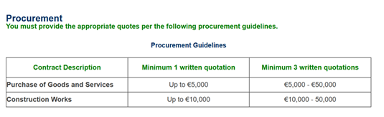
  All successful applicants must comply with the procedure outlined in the table below. Tendering Requirement: Supplies / Services/ Works
 | 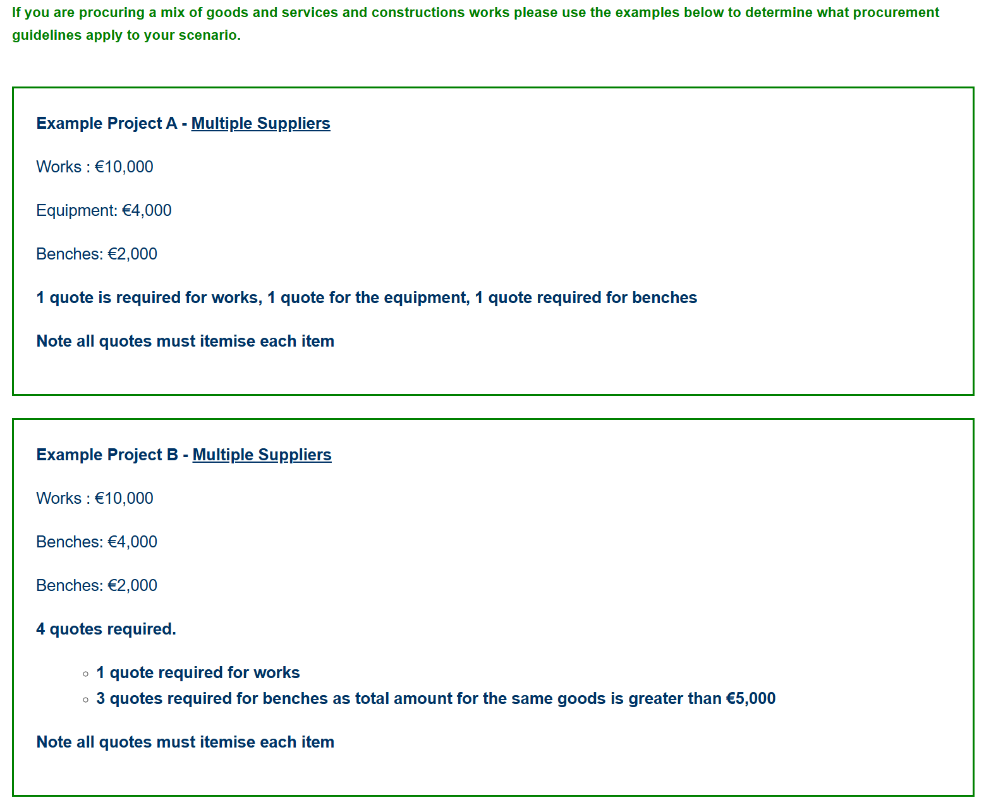
 | 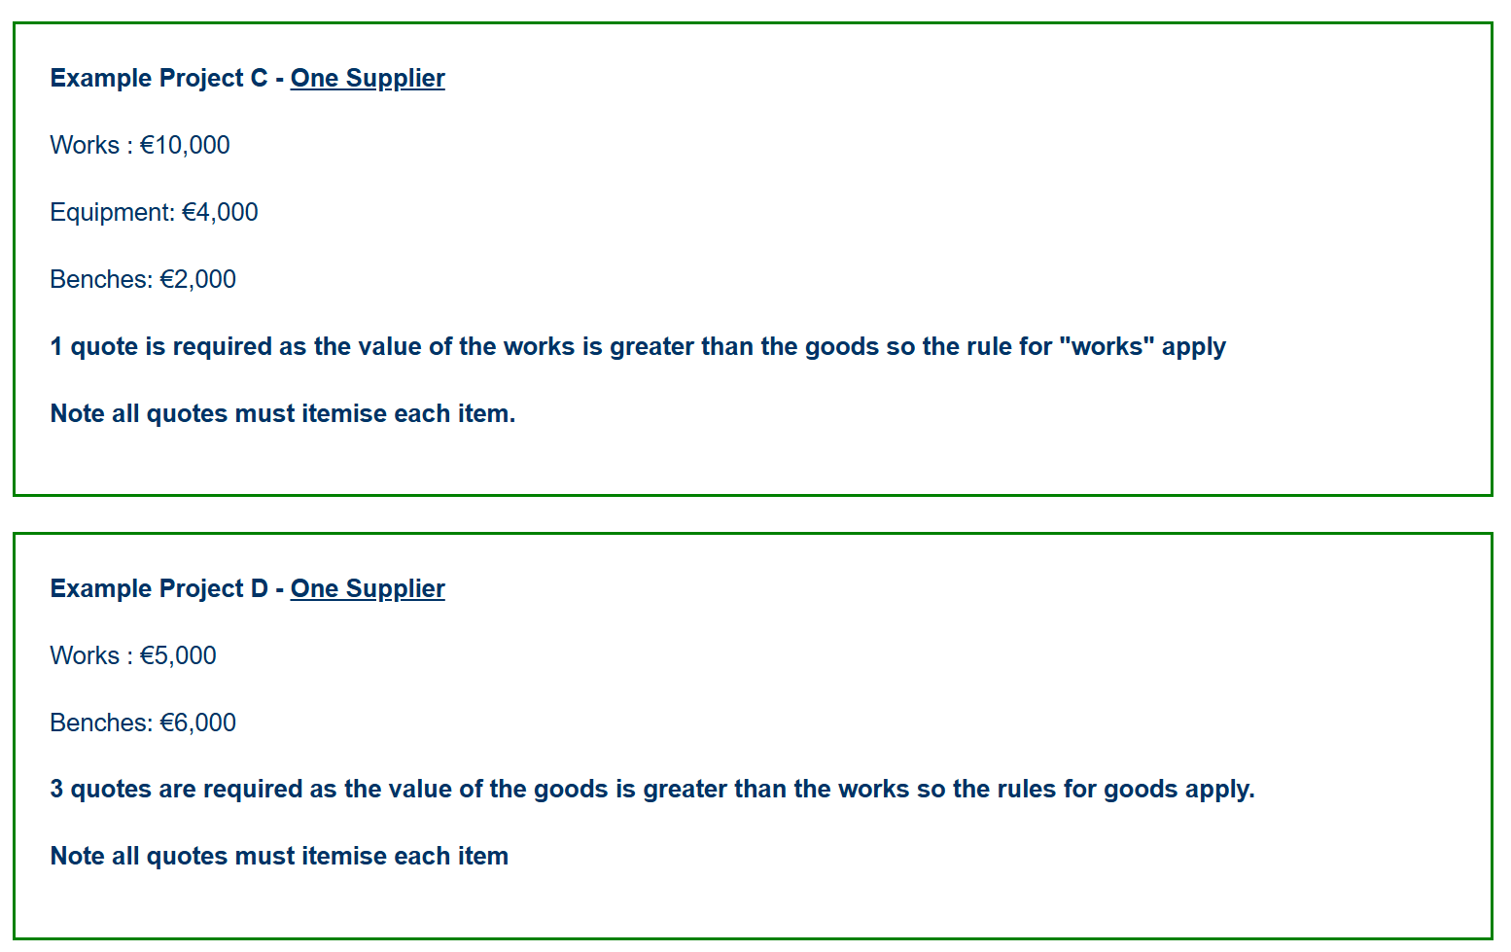
4.4 | Whether a grant is paid inclusive or exclusive of VAT will depend on the taxation status of the organisation.
4.5 | All applicants must include Roscommon County Council on their literature, marketing materials, websites and social media content as joint funder of a project once funding has been approved.

Appendix 1

State Aid and De Minimis
The LAG may offer funding to an applicant of no more than €200,000, which is within the de minimis threshold established for State aid. Public funding is deemed to be ‘State Aid’ where it provides the recipient, whether an enterprise, not-for-profit organisation, or an individual, an advantage over others. Such funding may be provided directly by the Exchequer or through other public bodies.
Generally, State aid rules only apply where the recipient of aid is deemed to be an ‘undertaking’. An undertaking is any entity involved in an economic activity, irrespective of its legal form, how it is financed, or whether or not it has a for profit orientation. Essentially, any activity that offers goods or services on a market is an economic activity.
To comply with State Aid rules, the level of funding provided to a project promoter must not exceed the €200,000 ceiling for State aid, known as the de minimis ceiling. The rules governing de minimis aid are set down in Commission Regulation (EC) 1407/2013.

Aid outside of De Minimis
Funding provided to community body applicants may not constitute State Aid and would not be subject to de minimis requirements. This is particularly the case where a project does not involve economic activity. Economic activity is defined as an activity that offers goods and services in a given market regardless of the legal status of the entity concerned. Accordingly, the LAG may offer funding of up to €500,000 for such community based projects (see section 9.2 – subject to final confirmation of eligibility conditions by DECLG).

