Office use only

**Return e-mail address :** [**planning@roscommoncoco.ie**](mailto:planning@roscommoncoco.ie)

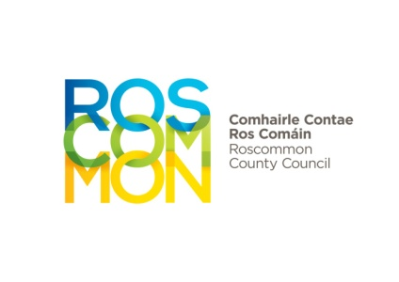

|  |  |
| --- | --- |
| Pre-planning ref. no. |  |
| Assigned Planner |  |

ROSCOMMON COUNTY COUNCIL - Request for Pre-Planning Meeting

**Name of Applicant:** _______________________________________________

**Address:** _______________________________________________

_______________________________________________

**Telephone Number:** _______________________________________________

**Email address:** _______________________________________________

**Agent details :** _______________________________________________

**Location of proposed**

**development:** _______________________________________________

________________________________________

**Nature and extent of**

**Proposed development:** ________________________________________

________________________________________

# Applicant’s legal Please tick - Owner

**interest in the site:**

**Option to purchase**

**Other**

**If ‘Other’, please specify**  ________________________________________

**If not the owner of site,**

**name and address of** ________________________________________

**owner:**

Where the applicant is not owner of the site, a letter consenting to a pre-planning query being made must be submitted by the owner of site with this application.

**I declare that all the information provided on this form, to be true and accurate.**

**Signed: __________________________ Date: _________________**

**Qualification**

Please note that any advice is given in good faith and without prejudice to the formal consideration of any subsequent planning application. Section 247 (3) of the Planning & Development Act 2000 (as amended) states that “the carrying out of consultations shall not prejudice the performance by a planning authority of any other of its functions under this Act, or any regulations made under this Act and cannot be relied upon in the formal planning process or in legal proceedings.” Formal consideration of an application is more extensive than consideration at the pre-application stage and includes for example the consideration of any internal technical reports, submissions from prescribed bodies and submissions from third parties.

**Documents to be submitted with this request:**

* **Site location map**
* **Draft site layout plan**
* **Site photos**
* **Detailed outline of the proposal**
* **Letter of consent from landowner (where relevant)**

**Please note that while it is not necessary to have the above prepared by an architect/agent, it is advisable to submit as much information as possible. Site levels / contours could be beneficial but are not mandatory.**

**The Planning Authority strongly caution against proceeding to commission detailed design proposals prior to the principle of the proposed development first being discussed at the initial pre-planning meeting.**

**A pre-planning meeting cannot be scheduled until the request form and associated documents are provided.**

**ALL E-MAIL REQUESTS TO BE SENT TO** [**planning@roscommoncoco.ie**](mailto:planning@roscommoncoco.ie)

**Please do not send pre-planning requests to the individual e-mail addresses of**

**Planning team members.**