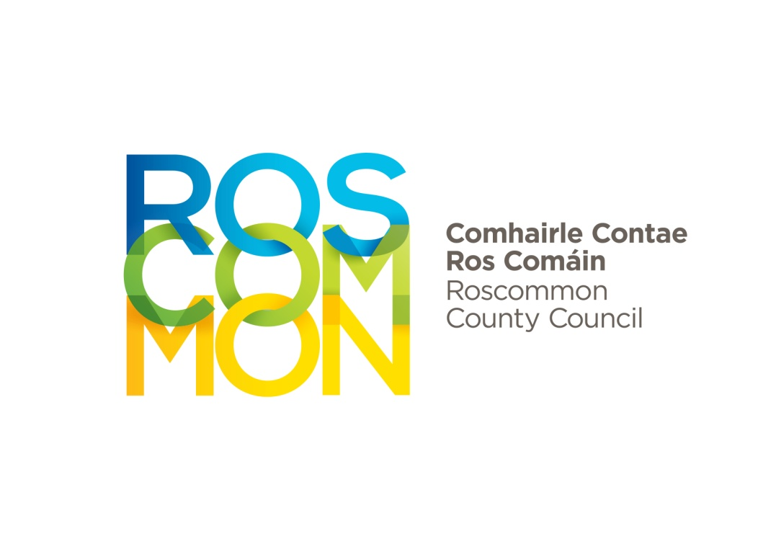
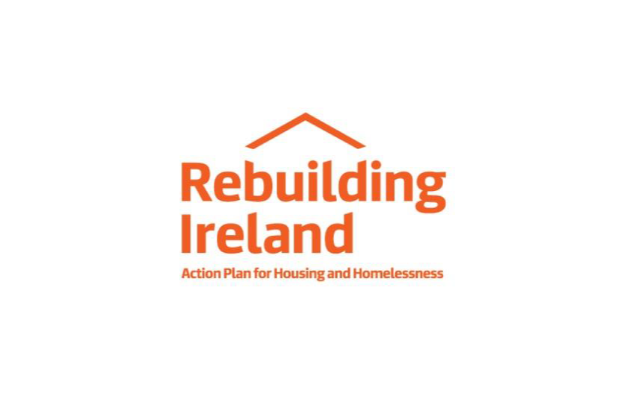

SALE OF SITE APPLICATION FORM
Section 1 – Personal Details
Applicant A |  |  |  | Applicant B
First Name: |  | Surname: |  | First Name: | Surname:
Date of Birth:  DD / MM / YYYY |  | PPS No: |  | Date of Birth  DD / MM / YYYY | PPS No:
□ Female □ Male |  |  |  | □ Female □ Male
Current Address: ___________________________  __________________________________________________________________  Eircode: |  |  |  | Current Address: ____________________________  ____________________________________________________________________  Eircode:
Daytime Phone: |  |  | Mobile / Home Phone: | Daytime Phone: |  | Mobile / Home Phone:
Nationality: |  |  |  | Nationality:
Marital Status: | Single □   Married □   Separated □   Divorced □   Widowed □   About to Marry □   Other □   Single Parent □

Section 2 - Confirmation of Eligibility
Eligibility Criteria | Applicant A |  | Applicant B
Have you ever owned or had an interest in any property? | □ Yes | □ No | □ Yes | □ No
If yes, give address, Folio No. and please state the special circumstances that apply that make you eligible for a Low Cost Site.

I have an indefinite right to remain in Ireland (either through nationality or refugee status). | □ Yes | □ No | □ Yes | □ No
If you are not a citizen of the European Union, you must submit evidence of entitlement to reside in Ireland (Stamp 4)
I am in full time permanent employment for at least six months (required for at least one applicant) | □ Yes | □ No | □ Yes | □ No

Section 3 - Dependents
Name | Date of Birth |  |  | PPS Number
1. | DD / MM / YYYY
2. | DD / MM / YYYY
3. | DD / MM / YYYY
4. | DD / MM / YYYY
Section 4 – Existing Accommodation | Please Tick Yes/No
 | Applicant A |  | Applicant B
Do you rent your current accommodation? | □ Yes  Monthly Rent: €________ | □ No | □ Yes  Monthly Rent: €________ |  |  |  |  | □ No
Are you living with parents/relatives | □ Yes | □ No | □ Yes |  |  |  |  | □ No
Are you a Tenant of a Local Authority or Voluntary/Co-Operative Body? | □ Yes | □ No | □ Yes |  |  |  |  | □ No
Are you a Tenant Purchaser of a Local Authority? | □ Yes | □ No | □ Yes |  |  |  |  | □ No
Have you applied to a Local Authority for Social Housing? | □ Yes | □ No | □ Yes |  |  |  |  | □ No

Section 5 – Financial & Employment Details
 | Applicant A |  | Applicant B
Occupation:
Number of years in full time employment:
Employer:
Employer's address:
Date of Commencement of present employment: | DD / MM / YYYY |  | DD / MM / YYYY
If current employment has been less than one year, state name and address of previous employer:
Gross Annual Income for previous tax year (enclose P60, P21) | € ___________ |  | € ___________
Current Annual Income (enclose four most recent payslips). See note below if self-employed: | € ___________ |  | € ___________
SELF-EMPLOYED: If you are self-employed, you must submit an Agreed Tax Assessment (signed and stamped by the Inspector of Taxes) together with Certified Audited Accounts for the tax year immediately preceding the date of application, together with Current Projected Income for the coming 12 months.
Do you have savings at a bank, building society, or credit union? | □ Yes | □ No | □ Yes | □ No
Total Accumulated savings: | €_________________ |  | €_________________
Please provide documentary evidence of savings if applicable, (Bank Statement etc.)
Do you have any outstanding loans? | □ Yes | □ No | □ Yes | □ No
Total Loan Balance: | €_________________ |  | €_________________
Repayment Amount: | €________ | □ Monthly | €________ | □ Monthly
Repayment Amount: | €________ | □ Weekly | €________ | □ Weekly
NOTE: Applications should be accompanied by a provisional letter of mortgage approval from a commercial lending institution where a mortgage is required for the purchase of the site and/ or the construction of a dwelling.

Section 6 - Area of Choice
1st Choice
2nd Choice

Section 7 – You must submit the following items with this application
A copy of a Birth Certificate or Passport for each applicant
Certificate of earnings or other official statements of earnings (i.e. P60, P21)
Copies of 4 most recent payslips (for both applicants if applicable)
Letter from employer confirming permanency of employment.
If you are self-employed, you must submit an Agreed Tax Assessment (signed and stamped by the Inspector of Taxes) together with Certified Audited Accounts for the tax year immediately preceding the date of application, together with Current Projected Income for the coming 12 months.
If you are not a citizen of the European Union, you must submit evidence of entitlement to reside in Ireland (Stamp 4).
SL.4 FORM attached - this form must be completed by the Revenue Commissioners on behalf of the applicant(s). Please contact them for details of your nearest office.
If applicable, please include details of separation or divorce documentation that indicates financial settlements that may be included as income.
Please note that any spouse must be included on the application as a joint applicant

Section 8 – Declaration
I/We declare that the information given in this form is correct to the best of my/our knowledge and belief.
I/We hereby authorise the relevant local authority to make any official inquiries necessary to process this application.
I/We understand that acceptance of this application form does not imply an acceptance by the Local Authority of your eligibility for a Low Cost Site.
Applicant A |  |  | Applicant B
Signed: |  |  | Signed:
Date: |  |  | Date:

PLEASE NOTE: All questions set out on the Application Form must be completed. In the event of non-completion or failure to submit required documents, your application form will be returned, as your application cannot be determined until all relevent facts are known.

FUTHER INFORMATION

INCOME ELIGABILITY TEST
Single Income Threshold
In the last income tax year, gross income (before tax) multiplied by 2.5 is €100,000 or less.

Two Income Household
The eligibility of a household with two earners is determined by a formula which takes account of the gross income (before tax), in the last income tax year, of the principal (greater) earner and subsidiary (lesser) earner as follows: where two and a half times the income of the principal earner plus once the income of the subsidiary earner does not exceed €100,000, the household is eligible.

SALE OF LOW COST SITES
Roscommon County Council may consider the development of further Low Cost Sites in Roscommon, which will be made available for sale to private individuals who wish to construct a dwelling house for their own occupation

Consideration will be given to persons in the following Categories:
- A person whose application for Local Authority Housing has been approved by the Local Authority.
- Tenants or tenant purchasers of local authority houses who wish to build a house for their own use and return their present house to the Local Authority.
- A tenant, for more than one year, of a house provided by a voluntary body under the Rental Subsidy Scheme & Capital Advance Leasing Facility Scheme who wishes to buy a private house and return his/her present house to the voluntary body.
- A member of a co-operative or non-profit housing group of which at least 75% of the members are either tenant/tenant purchasers or persons whose applications for local authority housing have been approved by the local authority.
- A person availing of a group or shared ownership project sponsored by a local authority or a building co-operative.

Please note that if your application is successful it will be necessary for the purchaser of a Low Cost Site to:

- Submit an application for planning permission within three months of the date of agreement.
- Commence development within twelve months of the date of the transfer of the site.
- Ensure that the dwelling being constructed is substantially complete within twenty-four months of the date of transfer of the site.
Submit this completed application form to:
Housing Business Unit,
Roscommon County Council,
Áras an Chontae,
Roscommon.
F42VR98
Phone: (090) 6637100 Email: housing@roscommoncoco.ie

- Cost of site (Forest View, Boyle €10,000)

