ROSCOMMON NEW WRITING AWARD 2021
for Short Fiction and Memoir
First Prize: €500
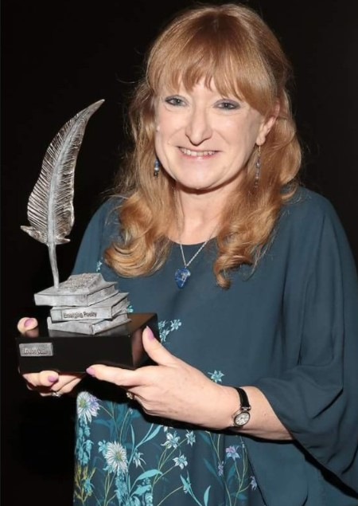
The ROSCOMMON NEW WRITING AWARD 2021 is organised as part of the county’s Literature Development Programme. It is funded by Roscommon County Council and The Arts Council of Ireland, supported by the Roscommon Herald and by Shannonside FM.
The winner will receive a monetary prize of €500 and will have their winning entry printed in the Roscommon Herald. An extract will also be broadcast on Shannonside FM.
Four runners-up will receive €100 each.

The Competition will be adjudicated by Louise G Cole.
Poet and short story writer Louise G Cole is a past winner of the New Roscommon Writing Award. She has won or been placed in local, national and international writing competitions, winning a Hennessy Award in 2018. She was chosen by Carol Ann Duffy for publication of the Laureate’s Choice pamphlet ‘Soft Touch’ in 2019. During the pandemic, Louise has been posting weekly creative writing prompts on her website, where she also explains the importance of the ‘G’ in her name (it avoids confusion with an underwear model) www.louisegcolewriter.com.

Closing date for entries is Monday, 24th May 2021.

Application forms and further information are also available here:
http://www.roscommoncoco.ie/en/services/community/arts-office/literature.html
For queries, please contact Áine Butler at abutler@roscommoncoco.ie. Tel (09066) 37271

The Roscommon New Writing Award Competition Rules

- Short stories and memoir pieces only will be accepted.
- Memoir entries may be stand-alone memoir essays, or they may be an extract from a longer memoir.
- The competition is open to anyone over 18. All entrants must have a connection with the county of Roscommon (born in, living in, currently working in, went to school in).
- Previous first prize winners may enter but will not be eligible for the first prize.
- Writers may submit up to two entries.
- Typed entries (handwritten entries cannot be accepted) must be no more than 2000 words. Mark the number of words in your entry on the bottom of the page. Entries over the 2000-word limit will be automatically disqualified.
- Include your name, address and contact details, plus your connection to the county. INCLUDE THESE ON A SEPARATE PAGE, NOT ON YOUR ENTRY.
- There is no entry fee. All entries must be received by Monday, 24th May 2021.
- The competition will be adjudicated by Louise G Cole. The judge’s decision is final.
- Email your entry to: artsofficer@roscommoncoco.ie .Title your email ROSCOMMON NEW WRITING AWARD 2021.
OR Post your entry to: ROSCOMMON NEW WRITING AWARD 2021, Roscommon Arts Office, Áras an Chontae, Roscommon, F42 VR98.

The names of the shortlisted writers will be announced in local media and online at http://www.roscommoncoco.ie/en/Services/Comm_Ent/Arts_Office/literature.htm.
Details of the awards ceremony will be announced at a later date.

