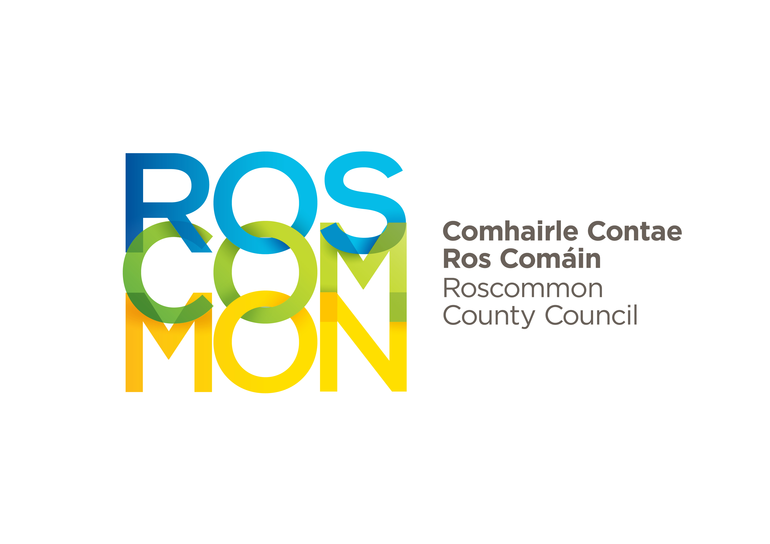
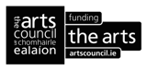

Roscommon County Council Arts Service Bursary Awards 2021

WRITER MENTORING PROGRAMME

APPLICATION FORM

NAME……………………….………………………………………………….………………………….................................................

ADDRESS…………………..……………………………………………………………………………...............................................

……………………………………………………………………………………………………………...................................................

TEL……………………………………............................... EMAIL………………………………………….………………................

WEBSITE ………………………………………………………………………………

PREFERRED MENTOR. You may, if you wish, provide the name of a mentor who you would like to work with. Should your application be successful, we will endeavour to make contact with your nominee. In the event that we are either unable to make contact, or if the proposed mentor is unable to undertake the assignment, we will engage another mentor and put them in touch with you.

Please write the name of your preferred mentor here: ……………………………………………………………

Detail here the project on which you wish to be mentored. A short paragraph will suffice.

Outline here why and in what specific way you believe you will benefit from being mentored.

All applications must be accompanied by a relevant (to the mentorship programme) sample of the writer’s work (no more than five pages) and an up-to-date and relevant CV.

Signed:___________________________________ ________ Date:_______________________

CLOSING DATE: 5pm, MONDAY 24th MAY, 2021

Email completed applications to artsofficer@roscommoncoco.ie

