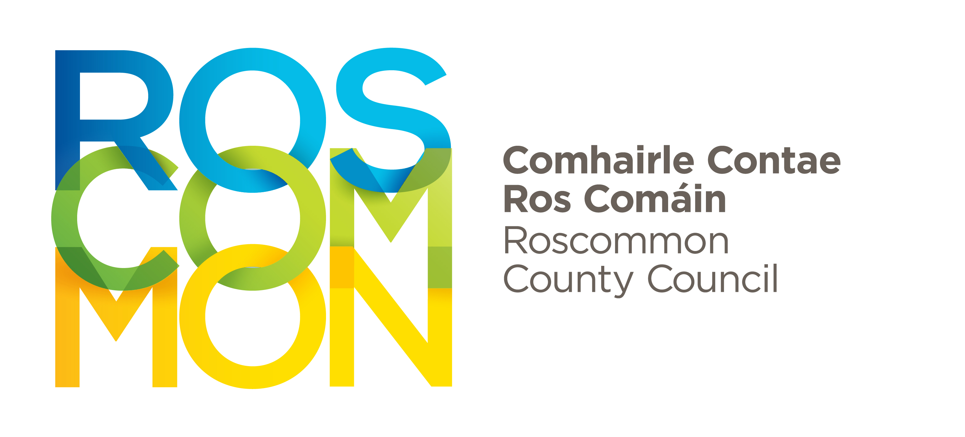
Roscommon County Council Arts Office 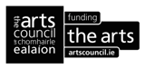

ROSCOMMON CHAPBOOK BURSARY 2022

APPLICATION FORM

NAME……………………….………………………………………………….…………………………..............................................

ADDRESS…………………..……………………………………………………………………………...............................................

……………………………………………………………………………………………………………..................................................

CONNECTION TO ROSCOMMON:………..………………………………………….......................................................

TEL……………………………………............................... EMAIL………………………………………….………………...............

List below the titles of either the poems or the stories that you propose to include in the chapbook.
All applications must be accompanied by proposed content of the chapbook (poems or stories) and a current biography and/or CV, outlining details of career to date.

Signed:___________________________________ ________ Date:_______________________

CLOSING DATE: 5pm, Friday, 20th May, 2022
Return Completed Applications to:
Email: artsofficer@roscommoncoco.ie with ’Roscommon Chapbook Bursary (applicant name)’ typed in the subject box.

Or Post to:
Roscommon Arts Office, Roscommon County Council, Áras an Chontae, Roscommon F42 VR98

