ROSCOMMON NEW WRITING AWARD 2022
for Short Fiction
First Prize: €750

The ROSCOMMON NEW WRITING AWARD 2022 is organised as part of the county’s Literature Development Programme. It is funded by Roscommon County Council and The Arts Council of Ireland, supported by the Roscommon Herald and Shannonside FM.
The winner will receive a monetary prize of €750 and will have their winning entry printed in the Roscommon Herald.
Two runners-up will receive €100 each.

The Competition will be adjudicated by Neil Tully.
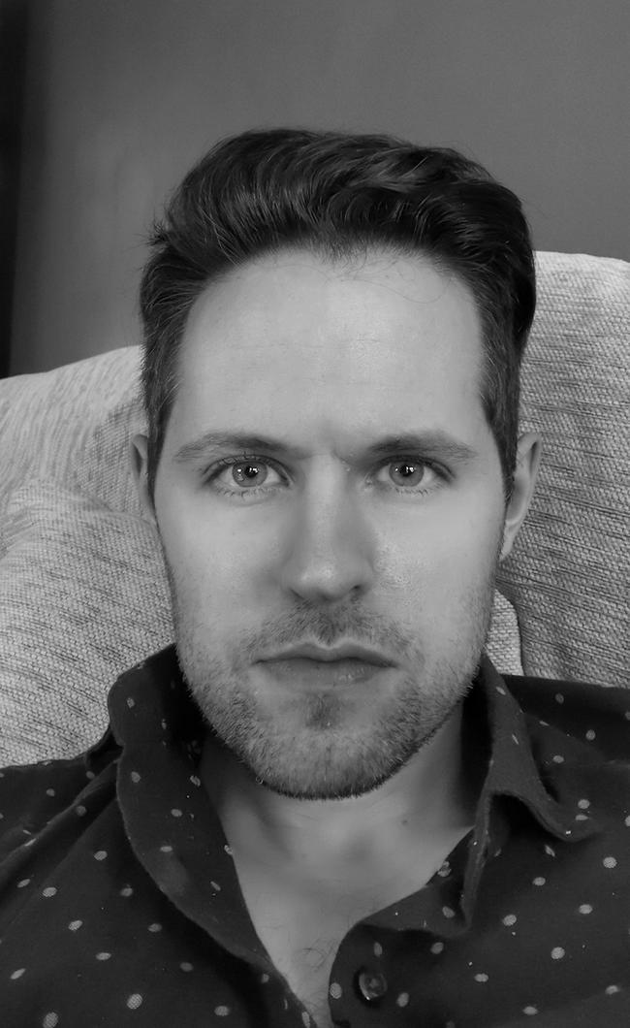
Neil won the overall prize and the short story prize at the Write by the Sea Literary Festival 2021. He also won the New Roscommon Writing Award 2021 and the Dock Arts Centre Short Story Prize 2020. He has been longlisted and shortlisted in many other competitions and his work has appeared in the Irish Independent, Quillette and elsewhere. He will complete an MA in Creative Writing at UL this year

Closing date for entries is Friday, 20th May 2022.

For queries, please contact Áine Butler at abutler@roscommoncoco.ie. Tel (09066) 37271

The Roscommon New Writing Award Competition Rules

- Short stories only will be accepted.
- The competition is open to anyone over 18. All entrants must have a connection with the county of Roscommon (born in, living in, currently working in, went to school in).
- Previous first prize winners may enter but will not be eligible for the first prize.
- Writers may submit up to two entries.
- Typed entries (handwritten entries cannot be accepted) must be no more than 2000 words. Mark the number of words in your entry on the bottom of the page. Entries over the 2000-word limit will be automatically disqualified.
- Include your name, address and contact details, plus your connection to the county. INCLUDE THESE ON A SEPARATE PAGE, NOT ON YOUR ENTRY.
- There is no entry fee. All entries must be received by Friday, 20th May 2022.
- The competition will be adjudicated by Neil Tully. The judge’s decision is final.
- Email your entry to: artsofficer@roscommoncoco.ie .Title your email ROSCOMMON NEW WRITING AWARD 2022.
OR Post your entry to: ROSCOMMON NEW WRITING AWARD 2022, Roscommon Arts Office, Áras an Chontae, Roscommon, F42 VR98.

The names of the shortlisted writers will be announced in local media and online at http://www.roscommoncoco.ie/en/Services/Comm_Ent/Arts_Office/literature.html
Details of the awards ceremony will be announced at a later date.

