**Speed meeting for slow art projects…**

**Networking for creativity in Roscommon 3-5pm, November 17, 2021.**

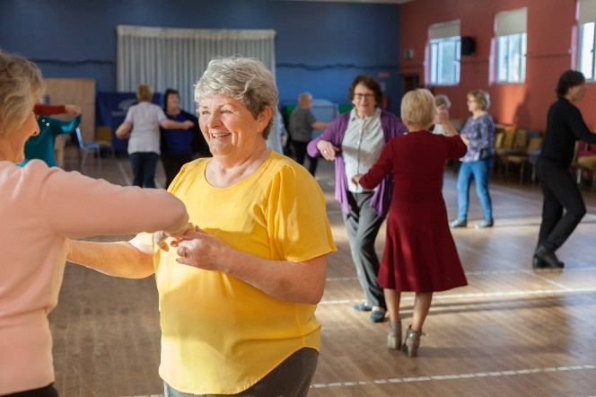 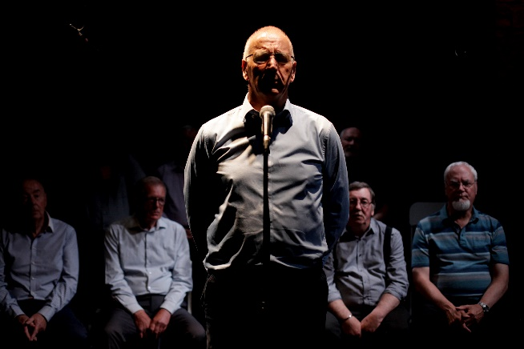

**Calling Professional Artists in Roscommon**

* Are you a professional independent artist who works with or would like to work with communities in Roscommon?
* Do you have an interest in working with **older people** or exploring subjects related to ageing in a collaborative approach?

Age & Opportunity’s Bealtaine Festival with Roscommon Arts Office wish to facilitate a (virtual) meeting between older person organisations and local professional artists, where they can chat about creative ideas and see if there is potential to work together in the future. If you would like to attend, please complete the application form below.

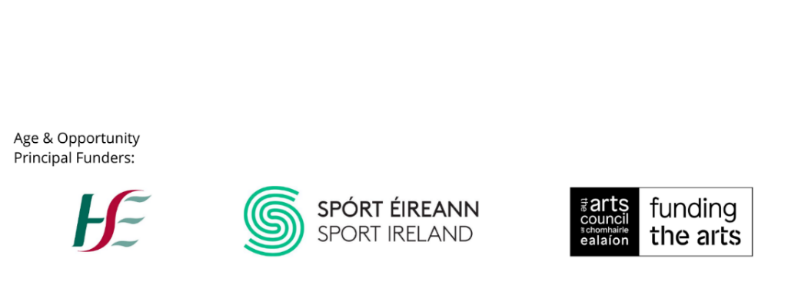

**Application Form for Artists – Speed Meeting for Slow Art**

If you are a professional artist who would like to attend this creative networking event on Wednesday 17th November (3-5pm), please fill out the details below and return to [artsofficer@roscommoncoco.ie](mailto:artsofficer@roscommoncoco.ie) by November 5th. Places are limited and will be assigned on a ‘best match’ basis.

|  |
| --- |
| Name: |
| Email: |
| Phone number: |
| Why are you interested in working with older people (100 words max)? |
| Please complete the questions below and tick this box to confirm you would like to share the information with the selected organisations  Short biography (1-2 lines):  Where you are in the county:  Anything else you feel is relevant (1-2 lines): |

*Please note that all information provided will be shared by Roscommon Arts Office with Age & Opportunity for the purposes of organising this event.*