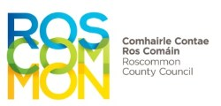 ROSCOMMON COUNTY COUNCIL
G.W.1.
Survey Sheet G.W.1 (September 1976) Ref. No. ___________________

County ____________________________ Name of Organiser _________________________________

Name of Scheme _____________________________________________Group Scheme Address of Organiser ___________________________________

Proposed Source _____________________________________________* ____________________________________________________

Nearest Town _______________________________________________ Telephone No. ________________________________________
 |  |  |  |  | Owners of agricultural land engaged in farming
 | Name | Townland | Cottage or Private House | No. of persons  in house | Agricultural land -  No. of acres | No. of Cows | No. of dry stock | Other stock  (e.g. pigs etc.) | No. of acres  under crops
1

2

3

4

5

6

7

8

* Mains Extension, Bored Well or Natural Source and where located.
Note: An owner of agricultural land is a person who has farming land as distinct from a cottier who has only a small plot of land around the dwelling.

