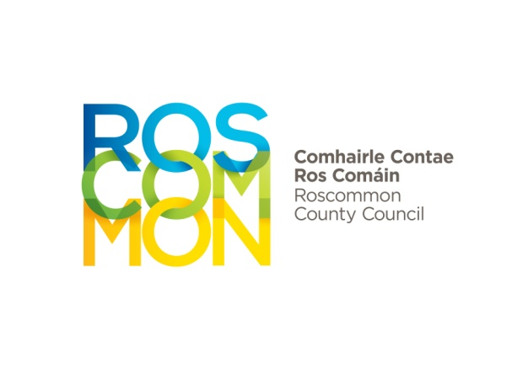

Roscommon County Council
Áras An Chontae
Roscommon
Telephone: 090 6637100

APPLICATION FOR TEMPORARY SIGN PERMIT IN RESPECT OF CHARITY,
SPORTING OR CULTURAL EVENT.

1. Contact details of Person responsible for erection and removal of sign | Name:  Address:  Phone No.
2. Please outline details of sign including type, size and materials used.

(Note-Paper signs covered with Plastic are not permitted).

3. Please outline the proposed wording of the sign including details of charity benefiting from the event.

4. Number of signs proposed to be erected

5. Please provide details of where the signs are to be erected, including map showing where signs will be located.

Permit Conditions Overleaf/

PERMIT CONDITIONS

- A bond of €150 is required. This bond is returnable if all conditions are met and signs are removed within the required period. Noncompliance may lead to non-refund of the bond.

- The size of any temporary sign shall not exceed that outlined in the Planning & Development Regulations 2001 (Class 9, 16,17 & 18)

- The Council may advise the applicant of more suitable locations for erecting signs taking into account road safety concerns.

- Signs are not allowed on roundabouts for road safety reasons.

- A temporary sign may not be erected more than 7 days before the event is due to take place.

- No temporary sign will remain up longer than 5 days after the event ceases.

- It is Council policy that no more than one sign may be erected per event on each approach road to a town or village.

- In cases where the event is run for charity, the name of the benefiting charity must be displayed on the advertisement.

- All signs must carry the name and address of the person who is promoting or arranging the meeting or event, or the name and address of the person on whose behalf it is exhibited.

- A fine of €150 will be issued for each sign not removed within the five days allowed.

- Signs should not be erected on Trees or Poles as this is an offence under the Litter Act.

Please complete and return this form to the Environment Office, Roscommon County Council, Áras An Chontae, Roscommon.

